AGH University of Krakow
WEAIIB, Department of Power Electronics and Energy Control Systems
Power Electronics Laboratory
-
GaN-Based High-Frequency Switched DC-DC Synchronous Buck Converter
-
Project Design Report

Prof. dr hab. inż. Robert Stala - Ekrem Turan Fırat
12.2025, Krakow, Poland
Project Purpose: Development of educational demo board with the possibility of observing by students the heating of the system elements with changes in parameters such as frequency, load, voltage and gain.

Stages 1: Circuit Parts & Block Diagram

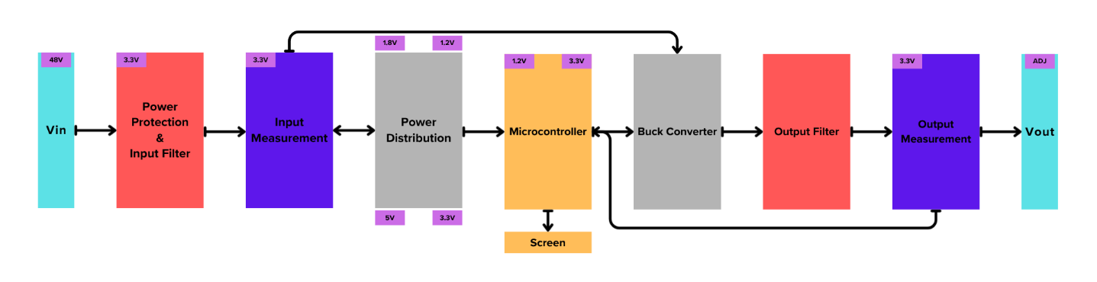
- Vin
  - This part is just the power input of the circuit.
- Power Protection & Input Filter
  - This component protects the circuit from factors such as over/under voltage, short circuits, overcurrent, and inrush current. It also filters the input from factors such as noise.
- Input Measurement
  - This part measures the input voltage and current.
- Power Distribution
  - This part distributes the input voltage to our operating voltage levels.
- Microcontroller
  - This part controls and supervises all systems. It performs many tasks, such as measuring input/output voltage/current, switching the buck converter, controlling the display, and adjusting output variables.
- Buck Converter:
  - This part includes the buck converter topology
- Output Filter
  - This part creates the filter for the output after switching.
- Output Measurement
  - This part measures the output voltage and current.
- Vout
  - This part is just the power output of the circuit.

Stages 2: Determining Electrical Values
- U_{IN} = 48V
- U_{OUT} = Adjustable
- F_{Sw} = adjustable
- L =
  - This value has a formula [1]: $\frac{U_{OUT} × \left(U_{IN }- U_{OUT}\right)}{∆I_{L} × F_{Sw} × U_{IN}}$
  - $ΔIL=0.3 × I_{OUT}$ and If our U_{OUT} = 12V and P_{OUT} = 100W then I_{OUT} = 8.33A & ΔI_{L} = 2.5A
    - Calculation factory of “0.3” is standard value.
  - Final calculation is $L= \frac{12V × \left(48V- 12V\right)}{2.5A ×500 KHz ×48V} =7.2μH$
- C_{IN} =
  - We need a bulk and filter capacitors for the input capacitors.
    - Bulk Capacitor Formula: $C= \frac{∆I × ∆t}{∆V}$ , If our $ΔI$ = 2A, $Δt$ = 10$μ$s, $ΔV$ = 1V
$C= \frac{2A × 10μs}{1V}$ = 20 $μF$
    - Input Filter Capacitors: It is aimed to create a wide-scale filter by adding 100 nF , 1 μF and 3.3 μF capacitors to the input filter capacitors.
- C_{OUT} =
  - This value has a formula [2]: $\frac{∆I_{L}}{8 × F_{Sw} × {∆V}_{OUT}}= \frac{2.5A}{8 × 500 KHz × 0.1}=6.25 μF$
NOTE: When selecting capacitors, MLCC X7R low tolerance capacitor selections are priority.

Stages 3: Component Selections
- Power Protection Parts

We need a power protection part for our circuit against dangerous situations such as short circuit and overvoltage, so we will use the TPS2492PWR from Texas Instruments eFuse IC in this circuit.

  - IC Calculations
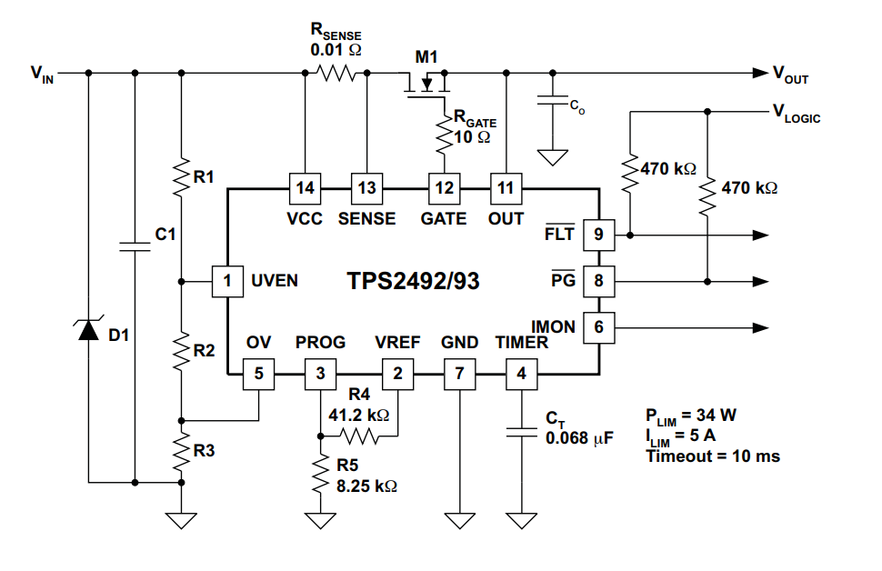
Figure [1] Typical Application Schematic
    - $I_{LIM}=\frac{50 mV}{R_{SENSE}}$ , If our current limit value is 10A, then R_{SENSE} value will be 5 mOhm.
    - Our threshold voltage value for the UVEN and OV pins is 1.35V, so if our supply voltage range is 44V up to 52V
      - $UVEN =44V×\frac{R2+R3}{R1+R2+R3} , OV =52V×\frac{R3}{R1+R2+R3}$ and OV = UVEN = 1.35V
      - Now our resistance values are R1 = 374 kOhm , R2 = 1.82 kOhm , R3 = 10 kOhm
    - $V_{PROG}= \frac{P_{LIM}}{10 × I_{LIM}}$ , We need to apply a value bigger than 0.4 V to this pin, and when we calculate, our result will be 1.2 mV. Therefore, we can't use this pin. We need to connect PROG and VREF with a 47 kOhm resistor. (In this case, the PLIM value is our power lost in the MOSFET, not the total power loss of the circuit.)
    - $C_{T}=\frac{36 μA}{4.1V} ×t_{ON}×\left(1+ C_{O-TOL}+ C_{T-TOL}\right) \& t_{ON}= \frac{C_{O} × V_{VCCMAX}}{I_{LIM}}$
        - C_{T-TOL} = Timer Capacitor Tolerance
        - C_{O-TOL} = Output Capacitor Tolerance
        - $t_{ON}=\frac{200 μF × 48V}{10A} =0.96 ms$
        - $C_{T}=\frac{36 μA}{4.1V} ×0.96 ms×\left(1+ 0.2+ 0.1\right)=11nF$

Texas Instruments - F28P650DK6PZPR
    - If we choose this MCU, It supports the high frequency PWM resolution. We can change the frequency and duty cycle with small movements.
    - Also this MCU has a two core. We can easily control the screen with the other core.
    - This MCU has a lots off PWM and ADC pins.
    - Price is 14.71€ per unite / 10.10€ per unite (100 Quantity)
- GaNFET:
  - The EPC2306, EPC2307, EPC2308, and EPC2367 were found to meet the desired range and specifications. Based on differences such as RDSon and size, it was decided to use EPC2367.
    - V_{DS} = 100V
    - R_{DS(on)} = 1.2 mOhm
    - I_{D} = 101A, Pulsed 420A
    - 3.3 * 3.3
- Temperature Sensor:
  - Texas Instruments - TMP119AIYBGR
    - It has high sensitivity and small size.
- Current Measurement:
  - Current Sense Amplifier: TI INA240
- Power Protection:
  - TPS2492PWR
References
[1], [2] B. Hauke, “Basic Calculation of a Buck Converter’s Power Stage,” Dec. 2011. [Online]. Available: www.ti.com

